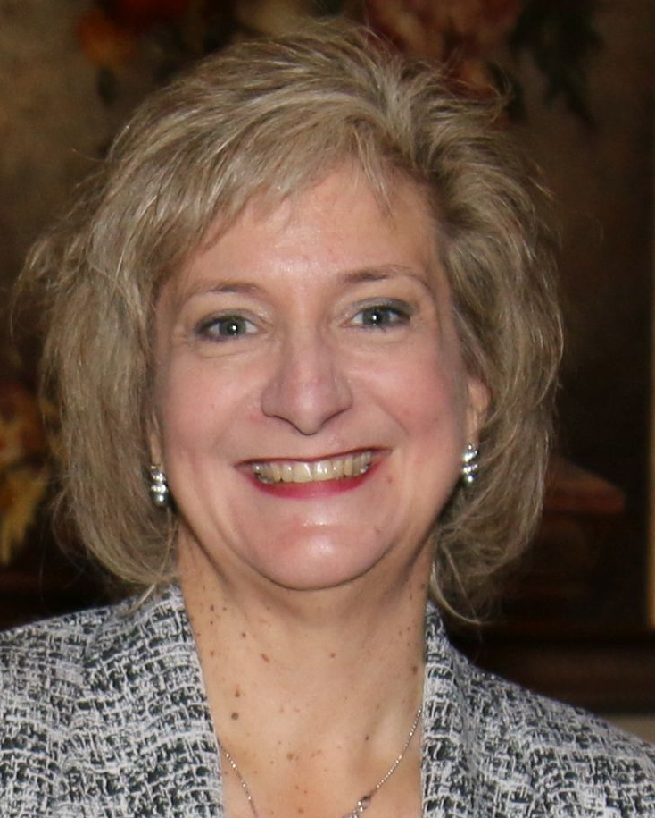

Melissa A. Cullen
Melissa, a Delaware native, has worked in the Human Resources field in the Dover area for over 20 years.

For the past 10 years, she has been the Human Resources Manager at Dover Downs Hotel & Casino in Dover, Delaware.

Melissa’s primary responsibilities include managing benefits for Dover Downs Gaming and Entertainment, Inc. and Dover Motorsports, Inc. employees, with specific focus on medical, dental and prescription benefits, along with short-term and long-term disability, worker’s compensation and 401(k).

Previously, Melissa worked for the Bayhealth Medical Center as a Benefits and Compensation Manager and for the State Personnel Office with the State of Delaware in Classification and Employment Services.

Education:
Melissa has a Bachelor’s Degree in Business Management from Wesley College.
Board Positions:
Melissa is the President of the DelMarVa chapter, Society for Human Resources Management.
In addition, Melissa is an 11-year member of the Magnolia Ladies Auxiliary that supports Magnolia and Kent County firefighters.

