Maria N. Clyde, PHR, SHRM-SCP
Director of Human Resources

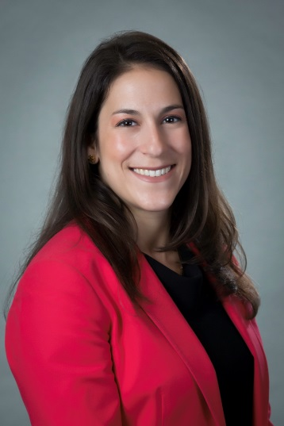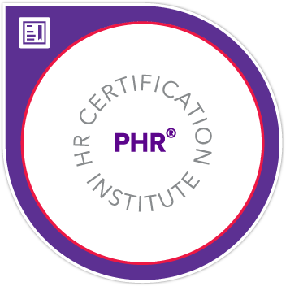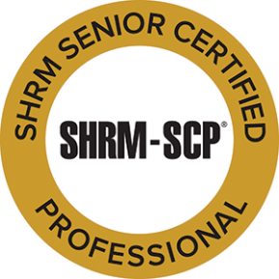

Maria N. Clyde, a certified Professional in Human Resources (PHR) and a Society of Human Resource Management (SHRM) Senior Certified Professional (SCP), has almost ten years of human resources consulting experience, and joined B+H Insurance (BHI) in late 2016. Maria handles human resources for the agency and assists clients with their in-house HR needs. This includes anti-discrimination and harassment training, manager training, reviews and assessments of current policies, employee handbooks, job descriptions, compensation structures, compliance requirements, and other HR or corporate development needs. As an active member of the Delaware Society of Human Resources Management (SHRM), Maria focuses on professional development and stays up-to-date with changing legislation affecting HR management. Before joining BHI, Maria worked as an HR Generalist for a mid-size government contractor in Washington, DC that serviced the Federal Aviation Administration as well as various Department of Defense agencies. In her spare time, she competes at Olympic weightlifting and enjoys cheering on her husband who is a competitive CrossFitter.

B+H Insurance (BHI)
Director of Human Resources
111 Ruthar Drive
Newark DE 19711
MClyde@BHI365.com
(c) 302-753-3062

